**Task 1. Create your AWS account with free tier:**

The steps for the creation of AWS with free tier:

1. Open the browser and search for AWS free tier account.
2. Visit the first link that is [AWS free tier](https://aws.amazon.com/free/?trk=2738afd4-9401-4d18-8e3e-1b1c194dea07&sc_channel=ps&ef_id=CjwKCAiAzc2tBhA6EiwArv-i6avq3MgW15S59YS00nS4TdNUY7B2znwZegRwc8mXyQJi3e47Nw0ychoCh_8QAvD_BwE:G:s&s_kwcid=AL!4422!3!509606977827!p!!g!!aws%20amazon%20com!12618685604!120373367976&all-free-tier.sort-by=item.additionalFields.SortRank&all-free-tier.sort-order=asc&awsf.Free%20Tier%20Types=*all&awsf.Free%20Tier%20Categories=*all) .
3. Click on the “Create a Free Account” button.

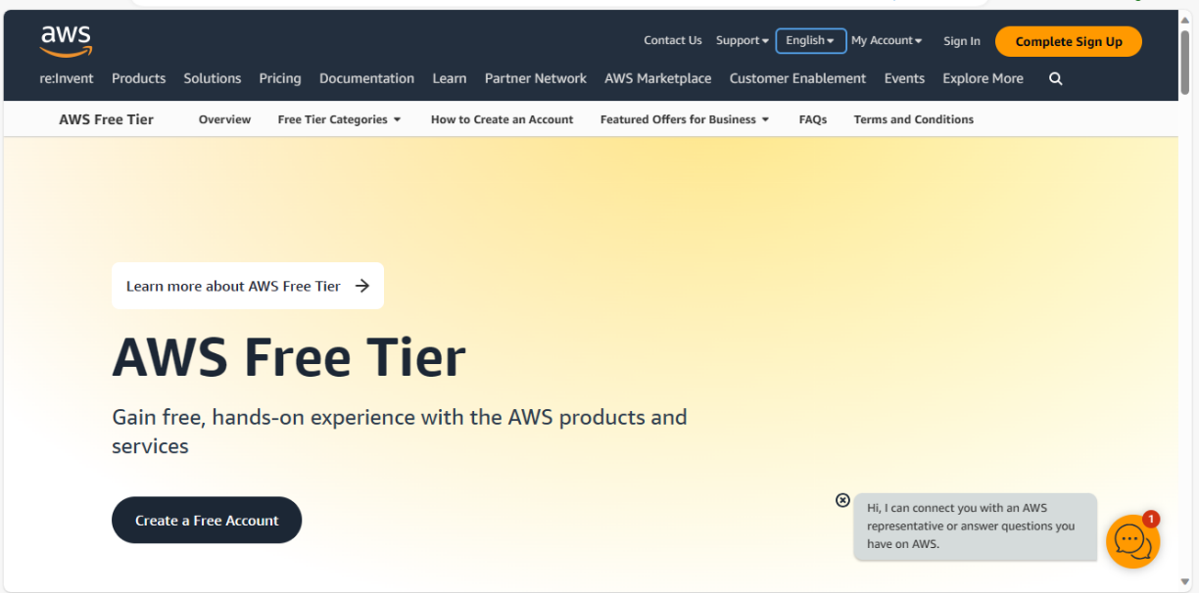

1. Then, Sign up for AWS fill the Root user email address and a appropriate AWS account name.
2. Click “Verify email address” and the enter the code sent to your inbox.

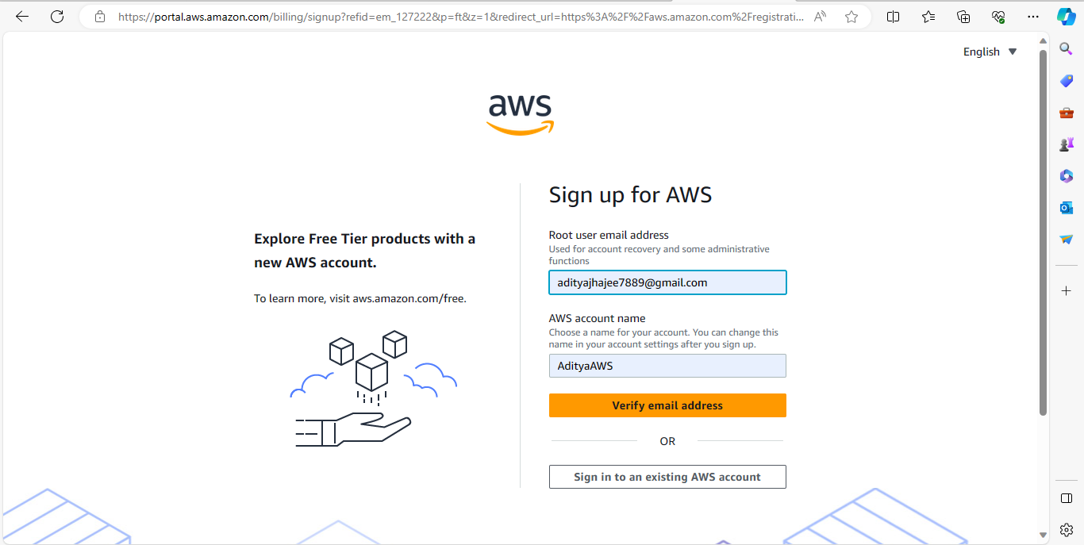

1. Now, create a strong password.

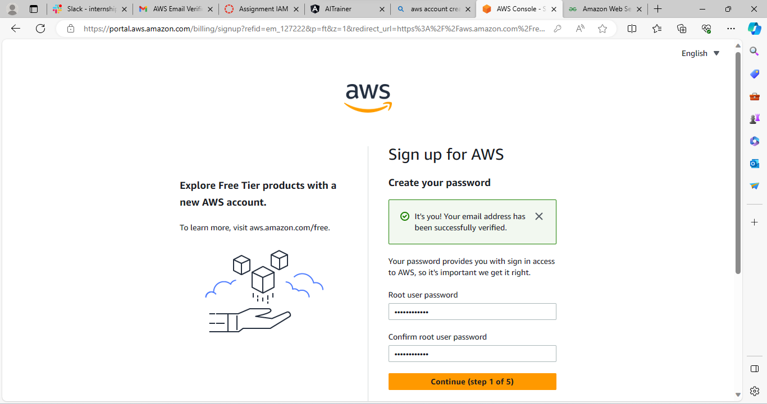

1. Fill in your contact information and billing details (Don’t worry, you won’t be charged it is for the bank account verification).

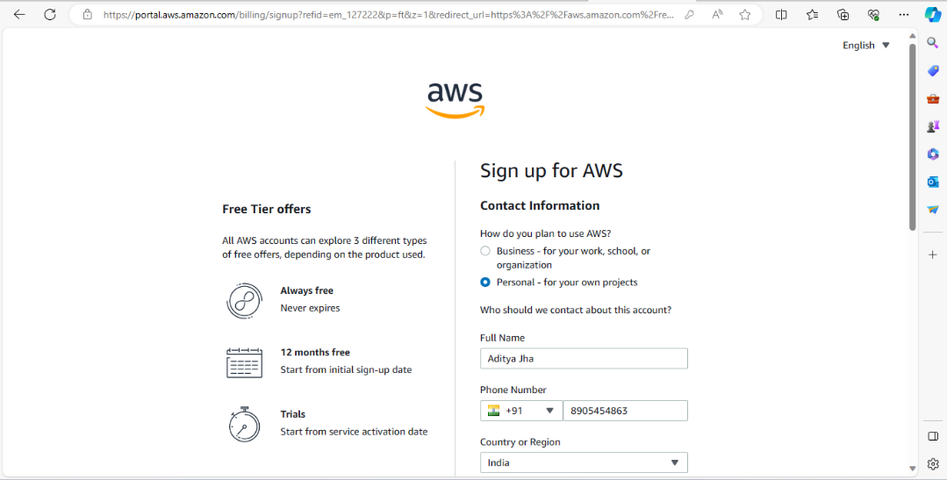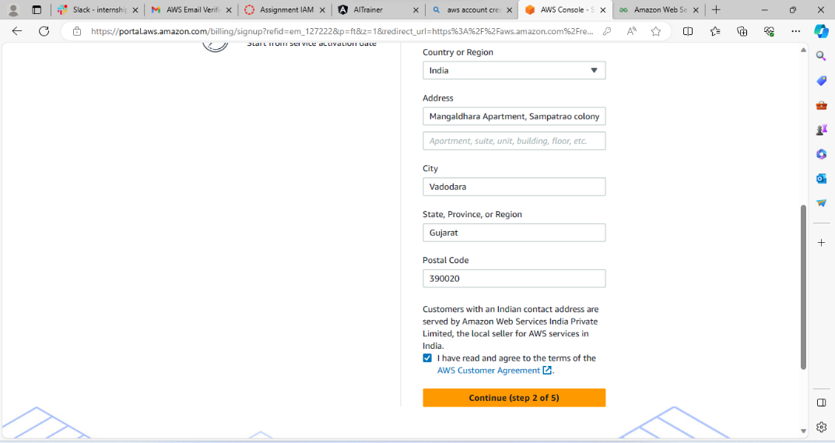

1. Then, confirm your identity and fill the details like account purpose, ownership type, Document type, Document no., and check the consent box.

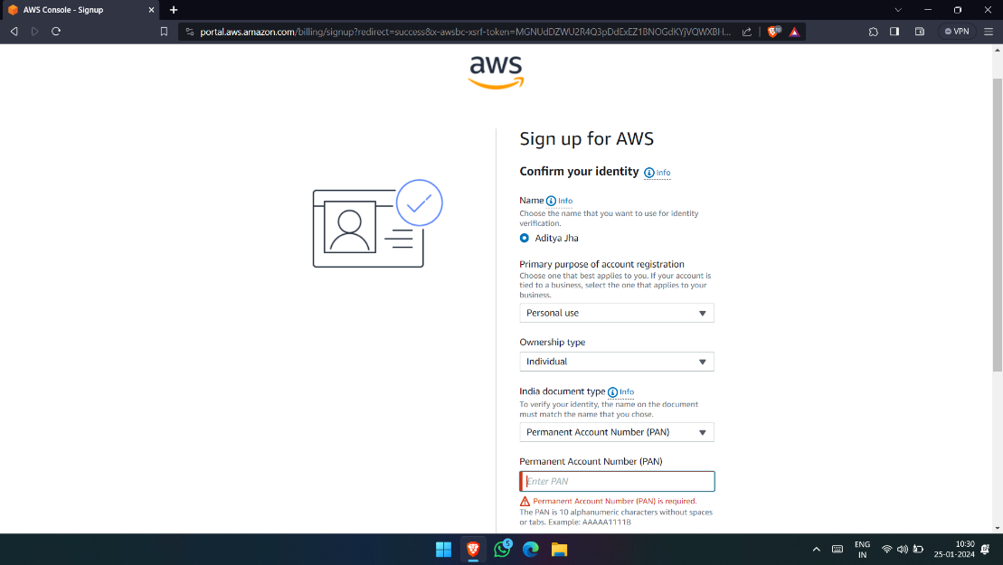

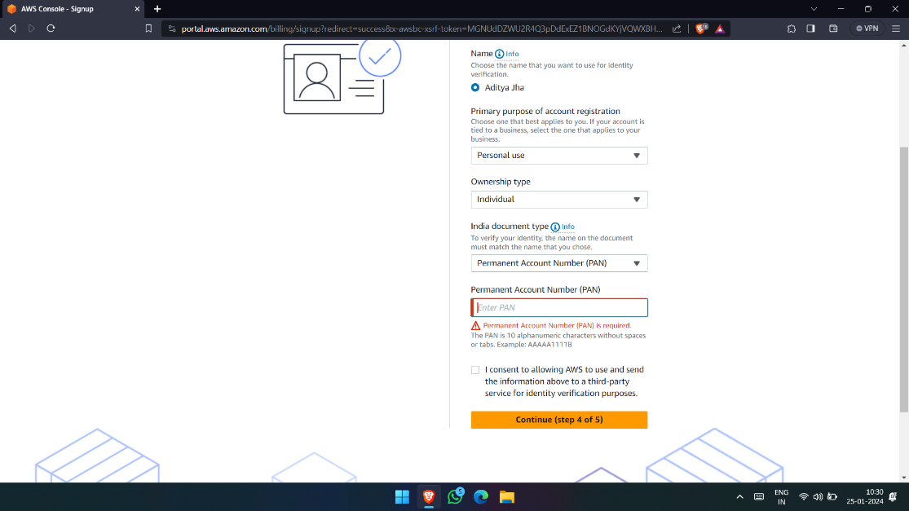

1. Then, verify your phone number.

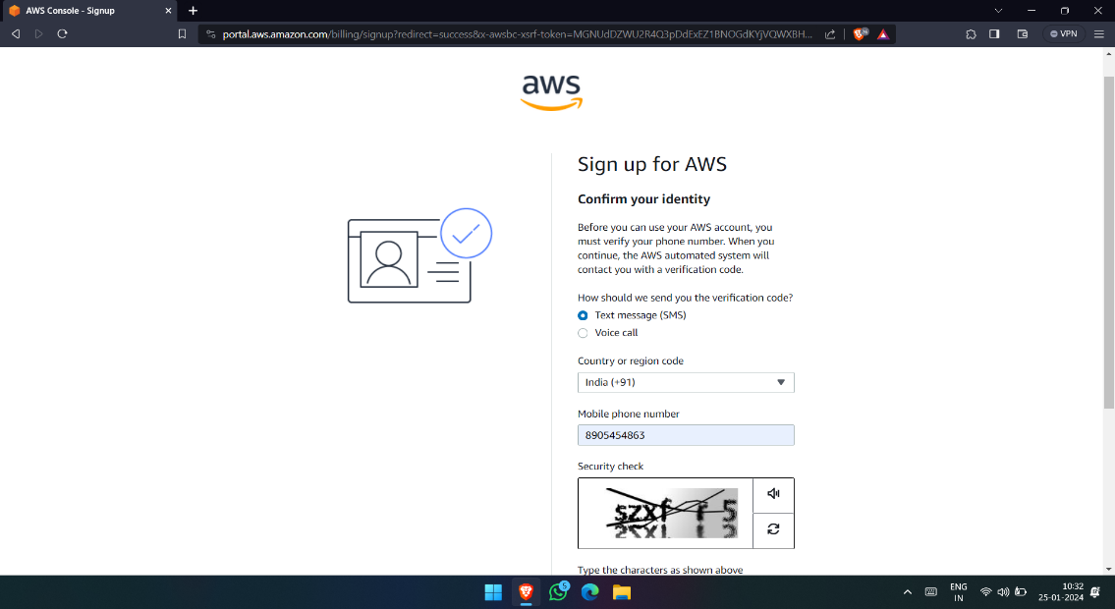

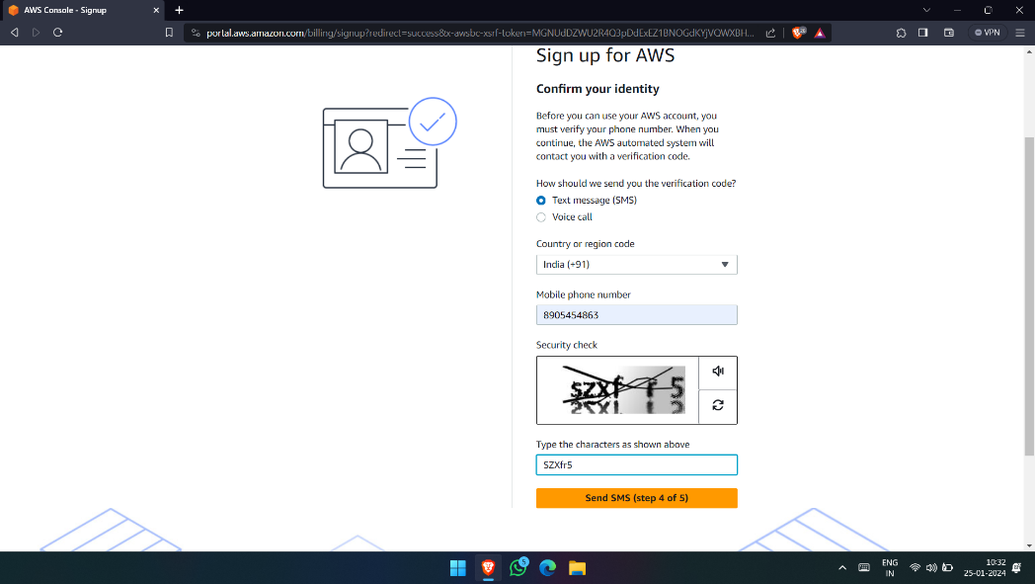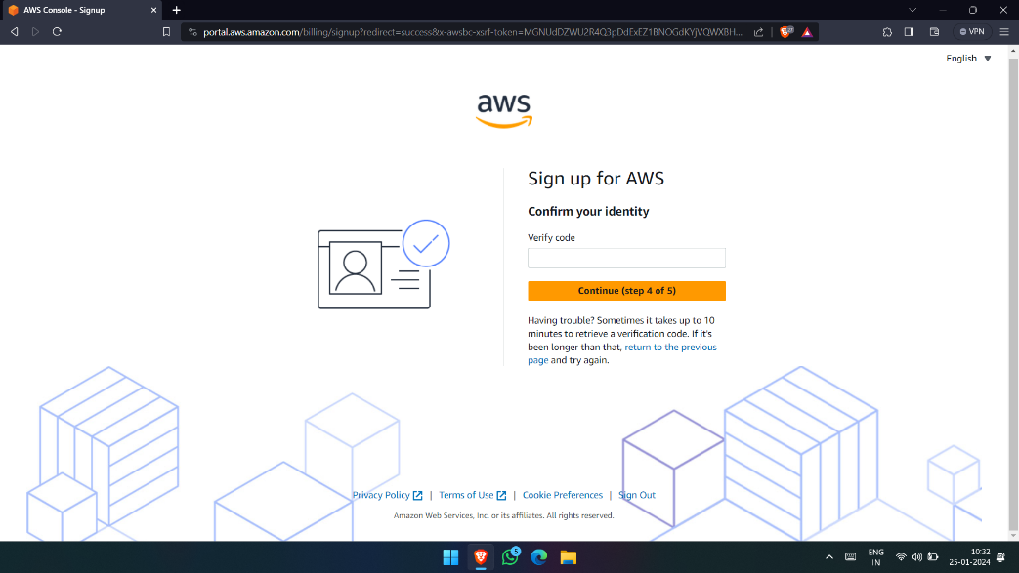

1. Select a support plan and continue.

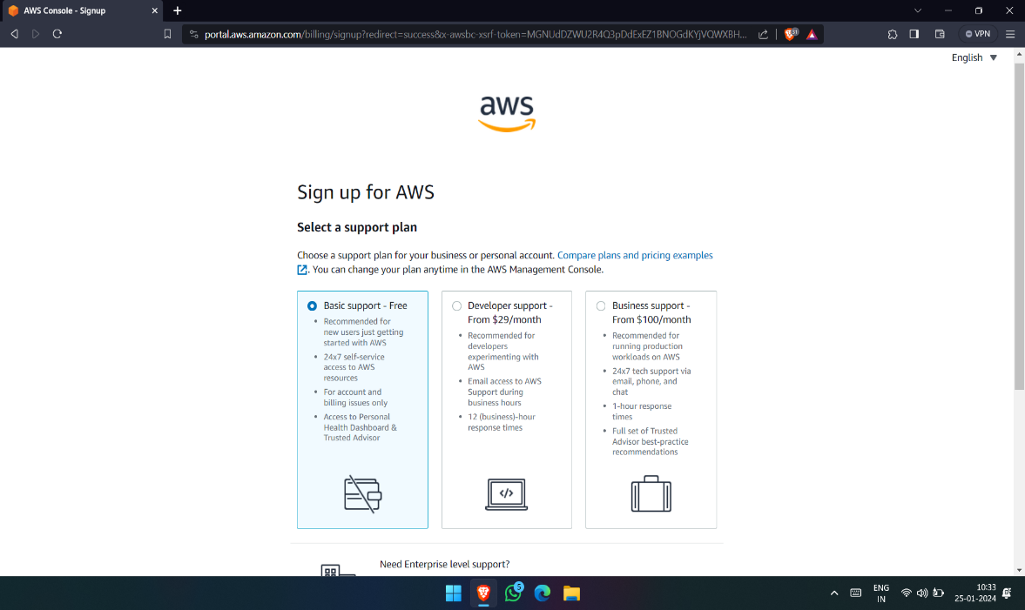

1. Congratulations account is created successfully now, personalise your experience.

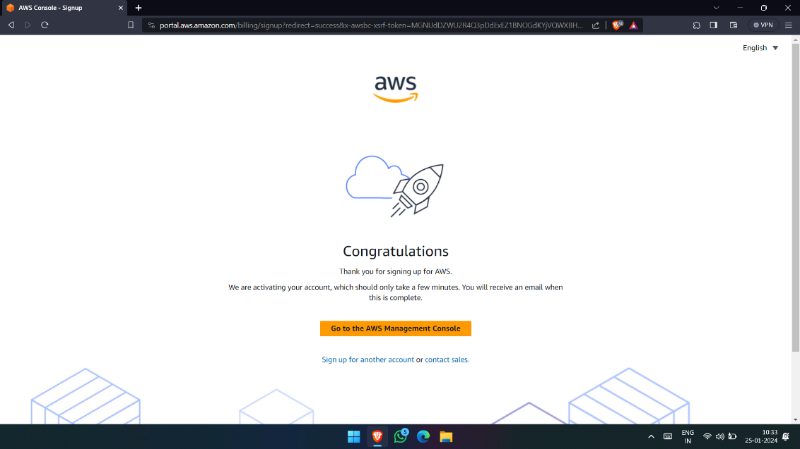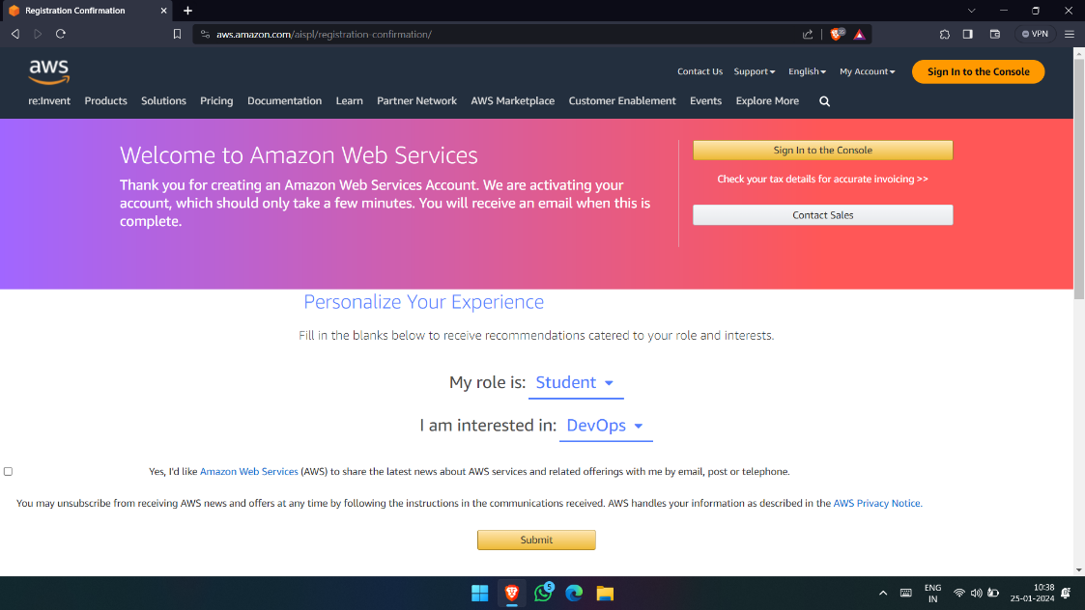

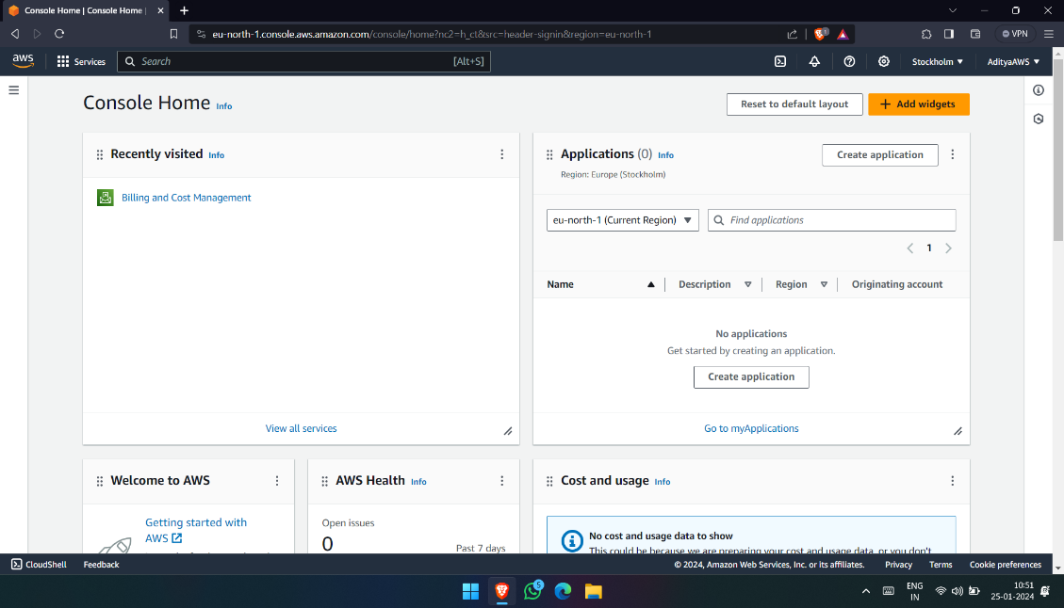 Now, sign in to console with the email id and the password.